Name : Aniruddha Pratap Singh
Year: AY 25-29
PRN: 25070122247
Semester: 3

ASSIGNMENT No: 5
TITLE: Implement a Java program to demonstrate inheritance and interfaces using suitable real-world examples.
Problem Statement :
Implement a Java program to demonstrate inheritance and interfaces using suitable real-world examples.
Theory:
Inheritance allows one class to acquire the properties and methods of another class, promoting code reuse and reducing redundancy. Java supports single inheritance through the extends keyword. Interfaces define a contract that implementing classes must follow, enabling abstraction and multiple inheritance of type. Together, inheritance and interfaces support polymorphism and modular software development. They are fundamental concepts of object oriented programming
Program :
interface Vehicle
{
void start();
}
class Car implements Vehicle
{
public void start()
{
System.out.println(&quot;car is starting.... &quot;);
}
}
class ElectricCar extends Car
{
void charge()
{
System.out.println(&quot;Electric Car is charging....&quot;);
}
}
public class InheritanceInterfaceDemo
{
public static void main(String[] args)
{
ElectricCar e = new ElectricCar();
e.start();
e.charge();
}
}
Output :
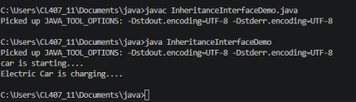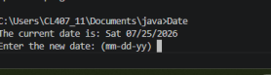
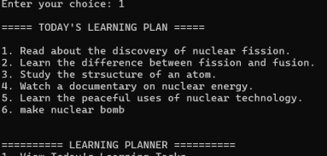
Exercise 1
Program :
abstract class Shape {
abstract void calculateArea();
}
class Circle extends Shape {
double radius;
Circle(double radius) {
this.radius = radius;
}
@Override
void calculateArea() {
double area = Math.PI * radius * radius;
System.out.println("Area of Circle: " + area); }
}
class Rectangle extends Shape {
double length;
double width;
Rectangle(double length, double width) { this.length = length;
this.width = width;
}
@Override
void calculateArea() {
double area = length * width;
System.out.println("Area of Rectangle: " + area);
}
}
public class ShapeApplication {
public static void main(String[] args) {
Shape circle = new Circle(5);
Shape rectangle = new Rectangle(10, 5);
circle.calculateArea();
rectangle.calculateArea();
}
}
Output:
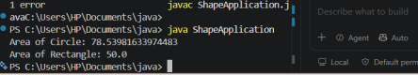2. Develop a E-Commerce Product System where electronic, clothing, and grocery products inherit common properties and implement product interfaces.
Source code:
import java.util.ArrayList;
interface Product {
void displayProduct();
double calculatePrice();
}
class ProductDetails {
String name;
double price;
ProductDetails(String name, double price) { this.name = name;
this.price = price;
}
}
class Electronic extends ProductDetails implements Product { int warranty;
Electronic(String name, double price, int warranty) { super(name, price);
this.warranty = warranty;
}
public void displayProduct() {
System.out.println("Product: " + name);
System.out.println("Price: " + price);
System.out.println("Warranty: " + warranty + " years"); }
public double calculatePrice() {
return price;
}
}
class Clothing extends ProductDetails implements Product { String size;
Clothing(String name, double price, String size) { super(name, price);
this.size = size;
}
public void displayProduct() {
System.out.println("Product: " + name);
System.out.println("Price: " + price);
System.out.println("Size: " + size);
}
public double calculatePrice() {
return price;
}
}
class Grocery extends ProductDetails implements Product { double weight;
Grocery(String name, double price, double weight) { super(name, price);
this.weight = weight;
}
public void displayProduct() {
System.out.println("Product: " + name);
System.out.println("Price: " + price);
System.out.println("Weight: " + weight + " kg"); }
public double calculatePrice() {
return price;
}
}
public class ECommerceSystem {
public static void main(String[] args) {
ArrayList<Product> products = new ArrayList<>();
products.add(new Electronic("Laptop", 60000, 2)); products.add(new Clothing("T-Shirt", 999, "L")); products.add(new Grocery("Rice", 1200, 10));
for (Product p : products) {
p.displayProduct();
System.out.println("Final Price: " + p.calculatePrice()); System.out.println("----------------------"); }
}
}
Output:
